**Department of Computer Applications**

**II MCA – Java Programming Lab Practice Test**

**Date:25.03.2024 Marks: 25**

Write a program which checks whether a patient’s blood pressure is normal or not and report it accordingly. You are required to define **two classes**.

* **Blood_Pressure**
* **Patient**

The **Blood_Pressure** should contain the following data members

1. **Upper**  //for upper value of the blood pressure
2. **Lower**  //for lower value of the blood pressure

The **Patient** class should contain the following data members

1. **Name** //for name of the patient
2. **BP** //for patient’s blood pressure, should be of type

Blood_Pressure

**You can add additional members in both classes by applying data abstraction. (extra credits)**

Write an **input** function for the class **Patient** that takes input for **Name** and **BP**. For **BP**, it should take input of **Lower** and **Upper**. Class **Patient** should also contain a member function that checks and reports whether the blood pressure is normal or not or etc based on chart below.

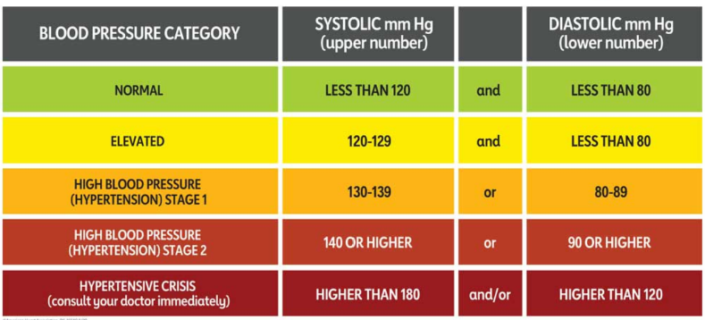

Write **setter** and **getter** functions for the data members; lower, upper and name in their respective classes. Also write **constructor** for each class. **Define driver function to create array of objects and test your code.**

***OUTPUT***

*Your output should be similar to the following*

***Enter patient name***

***Arun***

***Enter value for upper***

***120***

***Enter value for lower***

***80***

***Blood pressure is normal***

***Enter patient name***

***Krishnan***

***Enter value for upper***

***190***

***Enter value for lower***

***135***

***Blood pressure is not normal, Consult doctor immediately.***

2. Write a program that accepts the user feedback on the NPTEL course attended by the student. Obtain the following information from the student: mail id, roll number and usefulness score. Create custom exception classes for handling the NegativeScoreException and InvalidMailException. Validate the details obtained and raise exceptions when usefulness score is negative and the mail id is improper (check whether @ and. are present in the mail id provided).